DEPARTMENT OF AVIONICS ENGINEERING

SUBJECT : Digital Systems Microprocessors s Microcontrollers Lab
SUBJECT CODE : 308432

LAB NO : 04

TITLE : External Signal Measurements Input Capture using VS Code & AI

SUBMITTED TO : Engr M. Ali Ahmed
SEMSTER : 4th
SECTION : A

Marks Obtained
 | Group Member 1 | Group Member 2 | Group member 3
NAME | Sardar Ahmed Xaremann | M.Umer Khan | M.Rahid
REGISTRATION ID | 240701019 | 240701033 | 240701037
LAB REPORT
PERFORMANCE
TOTAL MARKS

DEADLINE:
DATE OF SUBMISSION:

WORK DIVISION TABLE

Project Component | Responsible Member | Primary Tasks
Code Development | Xaremann | Implementing 32-bit capture logic, ISR configuration, and XC8 math optimization.
Simulation & Testing | Umer | Proteus circuit setup, Signal Generator (10Hz) calibration, and LED verification.
Datasheet Analysis | Xaremann & Umer | Analyzing CCP1/Timer1 registers, overflow limits, and clock cycle timing.
Report Drafting | Rahid | Documenting the methodology, results, and formatting the final submission.

Introduction:
Embedded systems use two main ways to measure external signals. Method A uses software-driven External Interrupts (RB0), but it suffers from "Interrupt Latency"—a delay caused by the CPU saving its state before jumping to the code. While fine for human button presses, this jitter causes errors in high-speed sensors. Method B uses the Hardware Input Capture (CCP) module. This hardware instantly "snaps" a copy of the Timer1 value the moment a signal edge is detected, ensuring zero-latency, instruction-perfect accuracy. This lab also covers 32-bit math to measure low frequencies (like 10 Hz) that exceed the 16-bit hardware limit of 65,535 ticks.
Objectives:
The objectives for this lab report are as follows:
- Signal Measurement: To measure the duration and frequency of external digital signals with microsecond precision.
- Method Comparison: To contrast software-driven measurement using External Interrupts with hardware-accelerated Input Capture (CCP).
- Hardware Constraints: To understand hardware timer constraints and utilize overflow flags (TMR1IF) to handle human-scale interactions.
- Extended Timing: To master 16-bit timer rollover logic and implement 32-bit extended timing to measure low-frequency signals.
- AI Integration: To utilize AI-assisted development for register configuration and mathematical verification
Tasks:
Task #1:
Proteus Simulation:

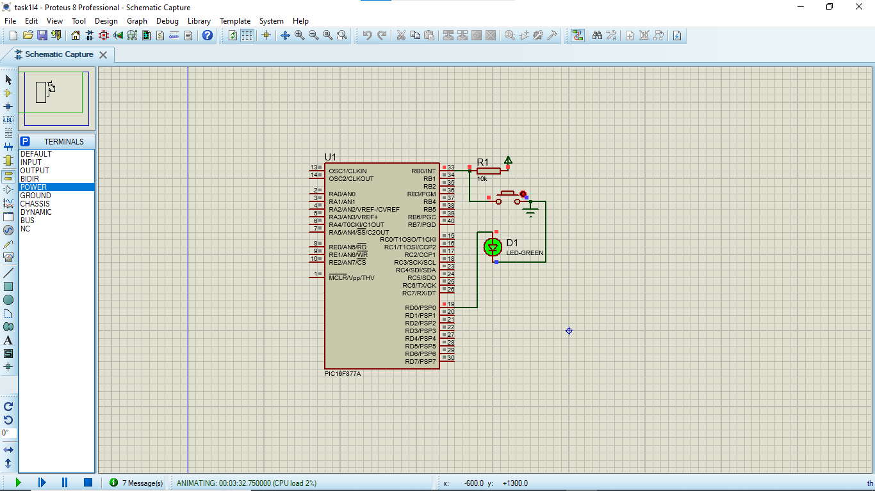
Code:
/*
* File: Lab4_PulseWidth_Software.c
* Target: PIC16F877A @ 4MHz
* Description: Measures human-scale pulse width using RB0 Interrupt and Timer1.
*/

#include <stdint.h>
#include <xc.h>

#define _XTAL_FREQ 4000000
#pragma config FOSC = XT, WDTE = OFF, LVP = OFF, BOREN = ON

uint16_t pulse_width = 0;
unsigned char edge_state = 0; // 0 = wait for press (falling), 1 = wait for release (rising)

void __interrupt() ISR(void) {
if (INTCONbits.INTF) {
if (edge_state == 0) {
// --- FALLING EDGE (Button Pressed) ---
T1CONbits.TMR1ON = 0; // Ensure timer is off before modifying
TMR1H = 0; TMR1L = 0; // Reset timer registers
PIR1bits.TMR1IF = 0; // Clear hardware overflow flag (Crucial for avoiding the trap)

T1CONbits.TMR1ON = 1; // Start Timer
OPTION_REGbits.INTEDG = 1; // Reconfigure interrupt to trigger on Release
edge_state = 1;
} else {
// --- RISING EDGE (Button Released) ---
T1CONbits.TMR1ON = 0; // Stop Timer
pulse_width = (uint16_t)((TMR1H << 8) | TMR1L);

/* TIMING LOGIC:
* Target: > 500 ms. At 8us/tick, 500ms => 62,500 ticks.
* Max Timer Capacity = 524 ms (65,535 ticks).
* If TMR1IF == 1, the timer rolled over (exceeded 524 ms).
* If TMR1IF == 0, check if the value is between 500 ms and 524 ms.
*/
if (PIR1bits.TMR1IF == 1 || pulse_width > 62500) {
PORTDbits.RD0 = 1; // Long press confirmed
} else {
PORTDbits.RD0 = 0; // Short press
}

OPTION_REGbits.INTEDG = 0; // Reconfigure interrupt to trigger on Press
edge_state = 0;
}
INTCONbits.INTF = 0; // Clear RB0 Interrupt Flag
}
}

int main(void) {
TRISBbits.TRISB0 = 1; // RB0 as Input
TRISDbits.TRISD0 = 0; // RD0 as Output
PORTDbits.RD0 = 0;

T1CONbits.T1CKPS = 0b11; // Timer1 Prescaler = 1:8 (1 tick = 8 us at 4MHz)
T1CONbits.TMR1CS = 0; // Internal Instruction Clock

OPTION_REGbits.INTEDG = 0; // Initial state: trigger on falling edge
INTCONbits.INTE = 1; // Enable RB0 External Interrupt
INTCONbits.GIE = 1; // Enable Global Interrupts

while(1) {
// CPU remains free for background scheduling
}
}
Explanation:
The Proteus simulation demonstrates a precise pulse-width measurement system using the PIC16F877A microcontroller. When the button on RB0 is pressed, an external interrupt triggers Timer1 to begin counting at an 8μs resolution (due to the 4MHz clock and 1:8 prescaler). Upon releasing the button, the simulation compares the accumulated timer value against a 500ms threshold ($62,500$ ticks); if the duration exceeds this limit, the LED on RD0 is toggled ON to indicate a "Long Press," otherwise it remains OFF. This interrupt-driven approach ensures the CPU remains efficient and responsive without constant polling of the input pin.
Task #2:
Proteus Simulation:

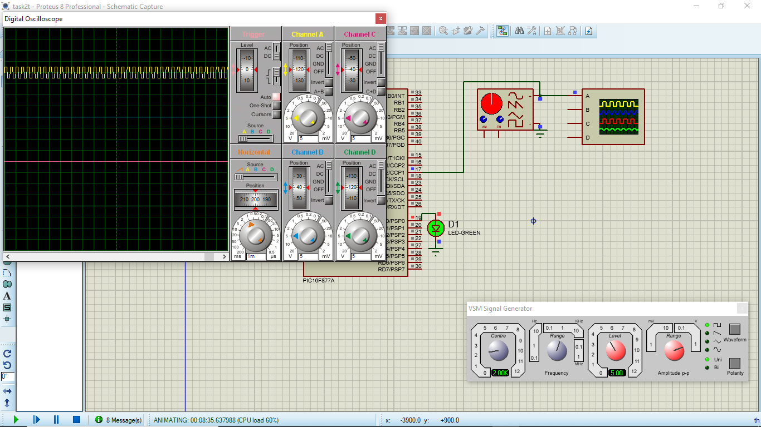
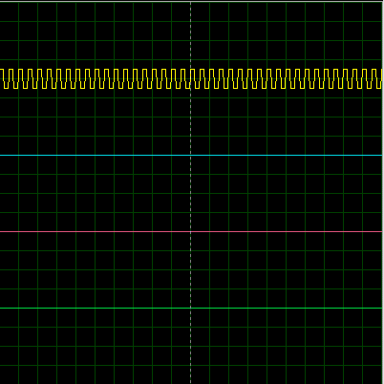

Code:
/*
* File: Lab4_Frequency_Match.c
* Target: PIC16F877A @ 4MHz
* Description: CCP1 Input Capture. Turns ON RD0 LED if a 2 kHz signal is detected.
*/

#include <stdint.h>
#include <xc.h>

#define _XTAL_FREQ 4000000
#pragma config FOSC = XT, WDTE = OFF, LVP = OFF, BOREN = ON

// Global variables for timestamp tracking
volatile uint16_t current_capture = 0;
volatile uint16_t previous_capture = 0;
volatile uint8_t overflow_count = 0; // Counts Timer1 overflows between captures
volatile uint32_t total_ticks = 0; // In case of overflow, total ticks exceed 65536 (16 bits)
volatile uint8_t capture_flag = 0; // uint8_t is equivalent to unsigned char, but more explicit about size

/*
In embedded C (especially with interrupts on PIC), volatile is a keyword that tells the compiler:
"This variable can change unexpectedly (e.g., by hardware or interrupts), so don't optimize it away."
Without it, the compiler might assume the variable never changes between accesses, leading to bugs
like stale data or infinite loops.

Best Practices
Always use volatile for variables shared between ISRs and main code.
For PIC: It's essential due to the 8-bit architecture and interrupt-driven design.
Alternatives: If not shared with interrupts, omit volatile to allow optimizations.
*/

void __interrupt() ISR(void) {
if (PIR1bits.TMR1IF) {
// Track Timer1 overflows so we can measure periods > 65535 ticks
overflow_count++;
PIR1bits.TMR1IF = 0; // Clear overflow flag
}

if (PIR1bits.CCP1IF) {
// Read 16-bit captured value
current_capture = (uint16_t)((CCPR1H << 8) | CCPR1L);

// Calculate elapsed ticks, accounting for timer rollovers.
// Apply conditional logic for 32-bit Total_Ticks (>65535):
// - Condition A (Current < Previous): The 16-bit subtraction already utilized one overflow lap.
// Subtract 1 from overflow_count to prevent double-counting.
// - Condition B (Current >= Previous): No rollover was consumed; use overflow_count as is.
uint32_t delta = (uint16_t)(current_capture - previous_capture);
if (current_capture < previous_capture) {
// Condition A: Subtraction used one lap
total_ticks = (uint32_t)(overflow_count - 1) * 65536UL + delta;
} else {
// Condition B: No lap used in subtraction
total_ticks = (uint32_t)overflow_count * 65536UL + delta;
}
overflow_count = 0; // Reset for next period

previous_capture = current_capture;

// Notify main loop
capture_flag = 1;
PIR1bits.CCP1IF = 0; // Clear flag
}
}

int main(void) {
// I/O Configuration
TRISCbits.TRISC2 = 1; // RC2/CCP1 as INPUT for Capture
TRISDbits.TRISD0 = 0; // RD0 as OUTPUT for LED
PORTDbits.RD0 = 0; // Initialize LED to OFF

// Timer1 Configuration (1:1 Prescaler)
T1CONbits.T1CKPS = 0b00;
T1CONbits.TMR1CS = 0;
T1CONbits.TMR1ON = 1;

// CCP1 Configuration (Capture mode, every rising edge)
CCP1CON = 0x05;

// Interrupt Enabling
PIR1bits.TMR1IF = 0; // Clear any existing Timer1 overflow flag
PIE1bits.TMR1IE = 1; // Enable Timer1 overflow interrupt
PIE1bits.CCP1IE = 1; // CCP1 interrupt enable
INTCONbits.PEIE = 1; // Enable peripheral interrupts
INTCONbits.GIE = 1; // Enable global interrupts

while(1) {
if (capture_flag) {

/* * IDEAL WORLD:
* 2 kHz => 500us period. At 1us per tick, period = 500 ticks.
* if (signal_period == 500) { ... }
* * REAL WORLD (Engineering Practice):
* Crystals have tolerances and drift. We should allow a small margin
* of error (e.g., +/- 2 ticks, which is +/- 0.4% error margin).
*/

if (total_ticks >= 498 && total_ticks <= 502) {
PORTDbits.RD0 = 1; // Turn ON LED (2 kHz match found)
} else {
PORTDbits.RD0 = 0; // Turn OFF LED (Frequency mismatch)
}

capture_flag = 0; // Reset flag until next capture
}
}
}
Explanation:
The Proteus simulation uses the CCP1 module to measure the time period of an incoming signal on pin RC2. If the captured time matches a 2 kHz frequency (approximately 500 timer ticks), the microcontroller identifies the signal and turns ON the LED at RD0. If the frequency changes or moves outside the $498–502$ tick range, the LED remains OFF, indicating a mismatch.

Task #3:
Proteous Simulation :

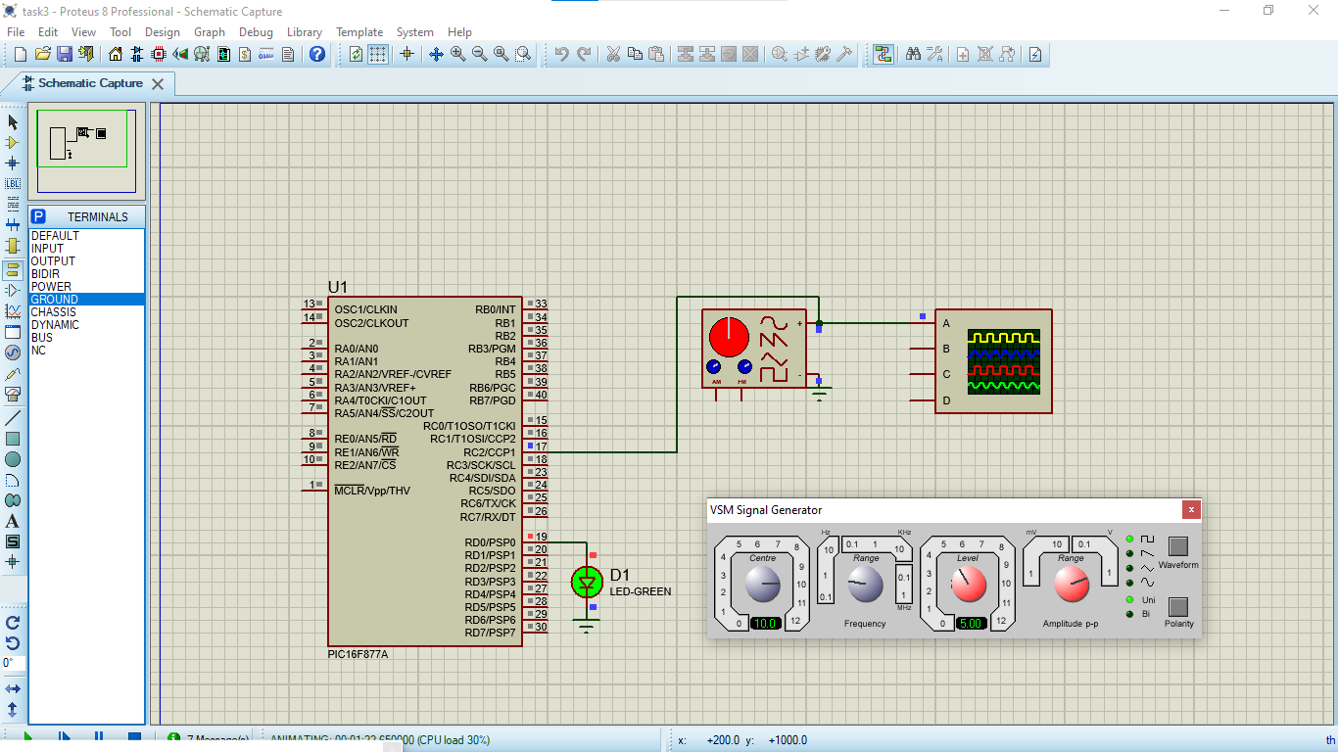
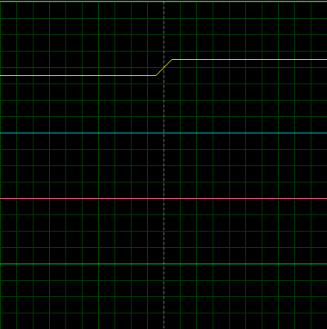

Code:
#include <xc.h>
#include <stdint.h>

#define _XTAL_FREQ 4000000

// ---------------- GLOBAL VARIABLES ----------------

// Capture values
volatile uint16_t previous_capture = 0;
volatile uint16_t current_capture = 0;

// Overflow counter (counts Timer1 rollovers)
volatile uint16_t overflow_count = 0;

// Final 32-bit ticks
volatile uint32_t total_ticks = 0;

// Flag to indicate new measurement
volatile unsigned char new_data_ready = 0;

// ---------------- INTERRUPT SERVICE ROUTINE ----------------
void __interrupt() ISR()
{
// ---------- TIMER1 OVERFLOW ----------
if (PIR1bits.TMR1IF)
{
overflow_count++; // count overflow
PIR1bits.TMR1IF = 0; // clear flag
}

// ---------- CCP1 CAPTURE ----------
if (PIR1bits.CCP1IF)
{
// Read captured value
current_capture = ((uint16_t)CCPR1H << 8) | CCPR1L;

uint16_t delta;

// -------- 16-bit subtraction --------
delta = current_capture - previous_capture;

// -------- 32-bit correction logic --------
if (current_capture < previous_capture)
{
// one overflow already handled in subtraction
total_ticks = ((uint32_t)(overflow_count - 1) * 65536UL) + delta;
}
else
{
total_ticks = ((uint32_t)overflow_count * 65536UL) + delta;
}

// Reset for next measurement
overflow_count = 0;
previous_capture = current_capture;

new_data_ready = 1; // signal main loop

PIR1bits.CCP1IF = 0; // clear flag
}
}

// ---------------- MAIN FUNCTION ----------------
void main(void)
{
// -------- PORT CONFIG --------
TRISC2 = 1; // CCP1 input
TRISD0 = 0; // LED output

RD0 = 0;

// -------- TIMER1 CONFIG --------
T1CON = 0x01; // Timer1 ON, prescaler 1:1

// -------- CCP1 CONFIG --------
CCP1CON = 0x05; // Capture mode, every rising edge

// -------- INTERRUPTS --------
PIE1bits.TMR1IE = 1; // enable Timer1 overflow interrupt
PIE1bits.CCP1IE = 1; // enable CCP1 interrupt

INTCONbits.PEIE = 1; // peripheral interrupt enable
INTCONbits.GIE = 1; // global interrupt enable

// -------- MAIN LOOP --------
while (1)
{
if (new_data_ready)
{
new_data_ready = 0;

// -------- 10Hz CHECK --------
// Expected = 100,000 ticks
if (total_ticks >= 99900 && total_ticks <= 100100)
{
RD0 = 1; // LED ON (frequency lock)
}
else
{
RD0 = 0; // LED OFF
}
}
}
}

Explaination :
The Proteus simulation uses the CCP1 module and Timer1 to measure the period of a low-frequency signal on pin RC2. By tracking timer overflows and capturing rising edges, the code calculates the total time between pulses; if this measurement matches a 10 Hz frequency (exactly 100,000 timer ticks), the LED on RD0 turns ON. Any frequency outside the narrow range of 99,900 to 100,100 ticks will turn the LED OFF, confirming the frequency lock has been lost.

Questions Asked In the Lab Manual :
QUESTION 1: Based on the architecture discussed in Theory Part 2, explain why software polled external interrupts (Exercise 1) are insufficient for calculating the frequency of a high speed 50kHz motor encoder signal.

Answer: Software-polled interrupts are insufficient for high-speed signals because a 50kHz signal has a very short period of only 20 microseconds. The CPU requires a specific amount of time to "notice" an interrupt, save its current state, and jump to the Interrupt Service Routine (ISR). This delay, known as latency, creates inconsistent "jitter" that can consume a massive percentage of the 20-microsecond window. Consequently, hardware-based Capture (CCP) is required to "snap" the timer value instantly via silicon logic, bypassing these CPU delays entirely.

Question 2: Data sheet Validation :

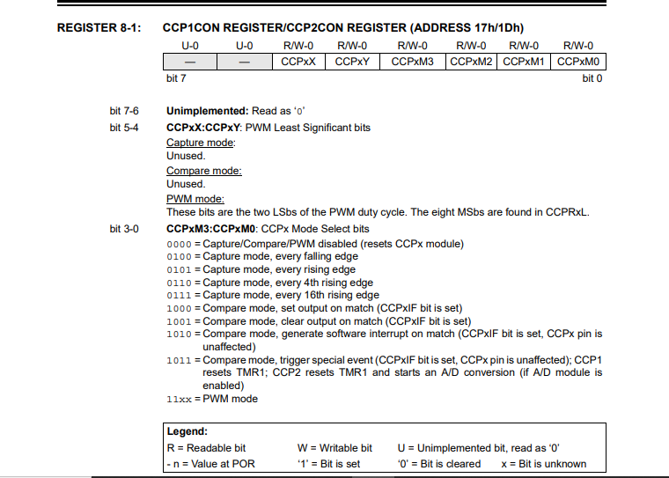
Register Explanation: CCP1M3:CCP1M0
The bits responsible for the capture behavior are Bits 3-0, known as the CCP1M (CCP1 Mode Select) bits. In your project, these bits are configured as 0101.
- Function: These four bits determine the specific operating mode of the CCP1 module.
- Rising-Edge Capture: According to the datasheet table, the bit pattern 0101 selects "Capture mode, every rising edge".
- Hardware Impact: When these bits are set to 0101, the hardware is instructed to monitor the RC2/CCP1 pin; as soon as a low-to-high transition occurs, the 16-bit Timer1 value is instantly transferred into the CCPR1 registers.
Question 3 : : In physical embedded systems, why is it mandatory to use a tolerance range (e.g., 99,900 to 100,100 ticks) rather than strict equality (₌₌ ₁₀₀₀₀₀) when validating external hardware frequencies?
Answer: In physical embedded systems, it is mandatory to use a tolerance range (such as 99,900 to 100,100 ticks) rather than strict equality. This is because real-world crystal oscillators have manufacturing tolerances and temperature drift, meaning a 10Hz signal may not result in exactly 100,000 ticks every time. Additionally, small variations in the signal or internal noise can introduce at least a ±1 count quantization error. Using a window ensures the "Frequency Lock" stays stable and reliable despite these unavoidable physical discrepancies.
Question 4: Explain the mathematical error that occurs if an engineer calculates
Total = (Overflow_Count x 65536) + (Current – Previous)
when the _{Current} capture value is 500 and the _{Previous} capture value is 65,000. Quantify the exact error in ticks.
Answer:
- 𝐼𝑛𝑐𝑜𝑟𝑟𝑒𝑐𝑡: ( 500 − 65,000 = −64,500 )𝑡𝑖𝑐𝑘𝑠
- 𝐶𝑜𝑟𝑟𝑒𝑐𝑡: ( (65,536 − 65,000) + 500 = 1,036 )𝑡𝑖𝑐𝑘𝑠
- 𝐸𝑟𝑟𝑜𝑟: ( 1,036 − (−64,500) = 65,536 )𝑡𝑖𝑐𝑘𝑠
A significant mathematical error occurs if an engineer fails to account for timer overflows when the current capture value is numerically smaller than the previous one. For instance, if the previous capture is 65,000 and the current is 500, a standard 16-bit subtraction naturally wraps around to yield a positive difference of 1,036 ticks. Because this subtraction already utilizes one overflow lap to resolve the difference, failing to subtract 1 from the software overflow_count results in double-counting that lap. This mistake creates an exact error of 65,536 ticks, which is the full range of the 16-bit timer.
Question 5: Calculate the absolute minimum measurable frequency f_{min} if the system utilized an 8-bit overflow_count variable at 4MHz. Show all relevant calculations.
Answer: The absolute minimum measurable frequency is determined by the maximum capacity of the 16-bit timer combined with the 8-bit overflow counter. At a 4MHz crystal frequency, the instruction clock is 1MHz, making each timer tick exactly 1 microsecond. An 8-bit counter can store up to 255 overflows, where each overflow represents 65,536 ticks. Multiplying these values results in a maximum measurable time of approximately 16.71 seconds, which translates to a minimum frequency of roughly 0.0596 Hz.
Question 6: Provide a screenshot of the simulation showing the Signal Generator interface and the indicator LED state
Answer : For a 10Hz signal at 4MHz, the expected period is exactly 100,000 ticks. Since this value exceeds the 65,535 limit of a 16-bit timer, the hardware will overflow once during the measurement. The software tracks this using an overflow_count and applies conditional logic to ensure the final 32-bit calculation is accurate. If the calculated total_ticks falls within the defined tolerance window of 99,900 to 100,100, the RD0 LED is programmed to turn ON, confirming a frequency match.
Conclusion :
This lab demonstrated that hardware-based Input Capture (CCP) is far superior to software polling for precision timing. By using the PIC16F877A’s internal silicon to "snap" timestamps, we eliminated CPU latency and achieved microsecond accuracy for frequency detection. We also implemented 32-bit math to accurately measure low-frequency signals, like 10 Hz, that exceed the standard 16-bit timer limit. Finally, using tolerance windows proved essential for real-world stability, ensuring the system remains reliable despite natural hardware drift

